Dated: August 09, 2022

JUIT Organize Event to Celebrate Dr. Har Gobind Khorana ‘Legendary Biochemist Birth Centenary’
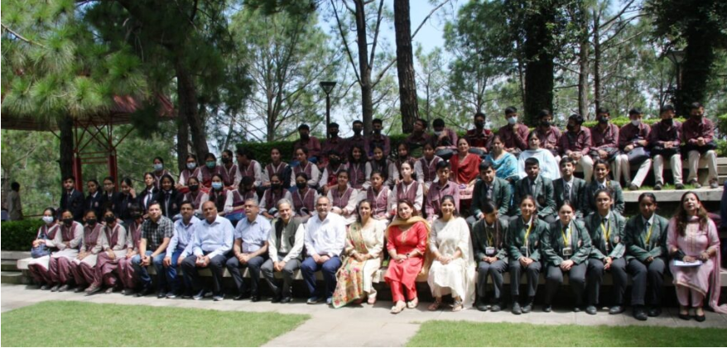

Solan, Aug. 09 -The Jaypee University of Information Technology (JUIT), Waknaghat organized an event to celebrate the 100th birth anniversary of Dr Har Gobind Khorana on the theme “Innovations in Science and Technology for healthcare, environment and industrial development“. Dr. Khorana shared the 1968 Nobel Prize for Physiology or Medicine with Marshall W. Nirenberg and Robert W. Holley for research that helped to show how the nucleotides in nucleic acids, which carry the genetic code of the cell, control the cell’s synthesis of proteins.
Various participants from different schools took part in the event for quiz competition, oral presentation and poster presentation. The event started with speeches from the VC, Dr Rajendra Kumar Sharma, dean of Academics & Research, Dr Ashok Kumar Gupta and the HOD of the Biotechnology and Bioinformatics department, Dr Sudhir KUmar. Then, the competition for the various events started and the participants participated with full enthusiasm. The participants were judged by Dr Hemant Sood and Dr Saurabh Bansal of the BT &BI department, JUIT.
The winners of the quiz were Onamh Sharma and Eklavya Chauhan from MRA DAV public school, Solan. The winner of the poster competition was Ananya Verma from DAV public school, New Shimla. The winner of the oral presentation was Anusha Joshi from Gurukul International senior secondary school. After announcing the winners the faculty coordinators from JUIT and the faculty coordinators were given a token of appreciation from VC Dr RK Sharma. Then, the event concluded with a vote of thanks from Dr Shikha Mittal and Dr Poonam Sharma, the faculty coordinators of the event.

